# TESTS RESULST

## COMPONENT TESTS

Measurement of inductance;

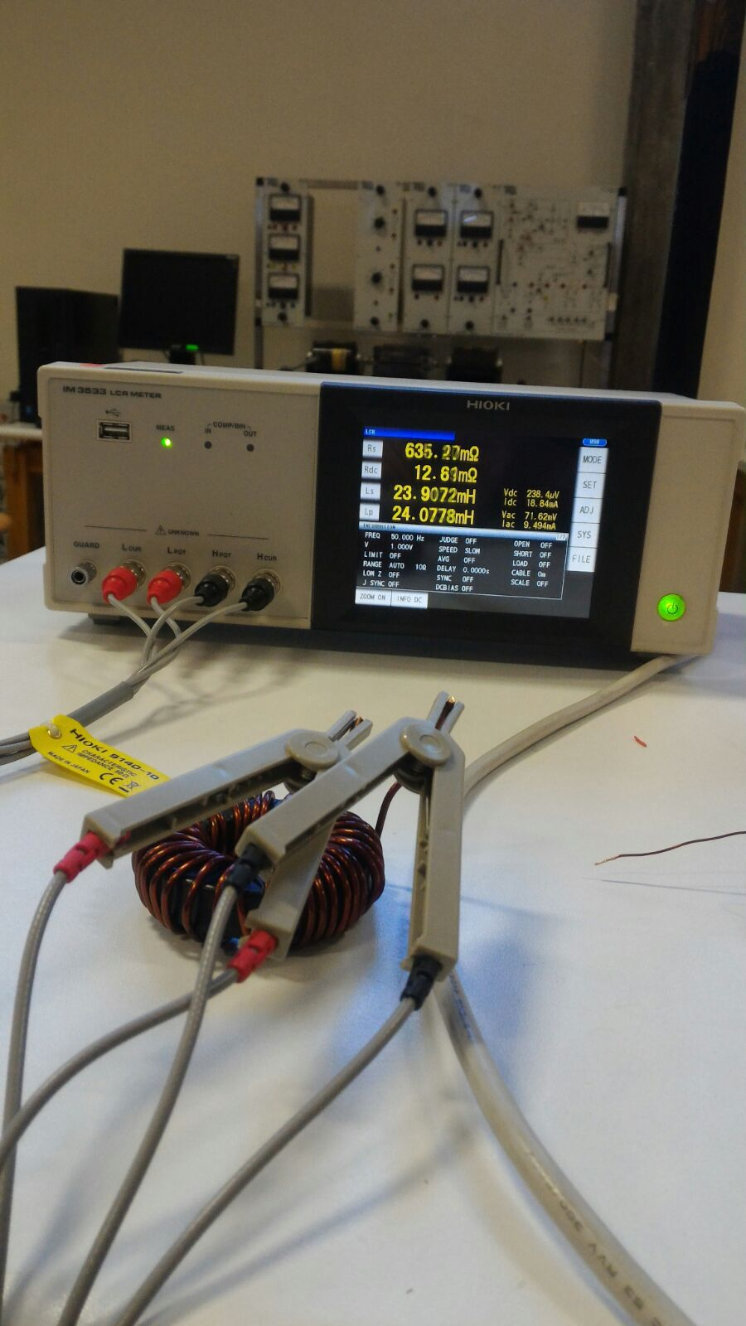

Figure 2.Inductance of Component Planned to Use in Buck Converter

Saturation of inductor;

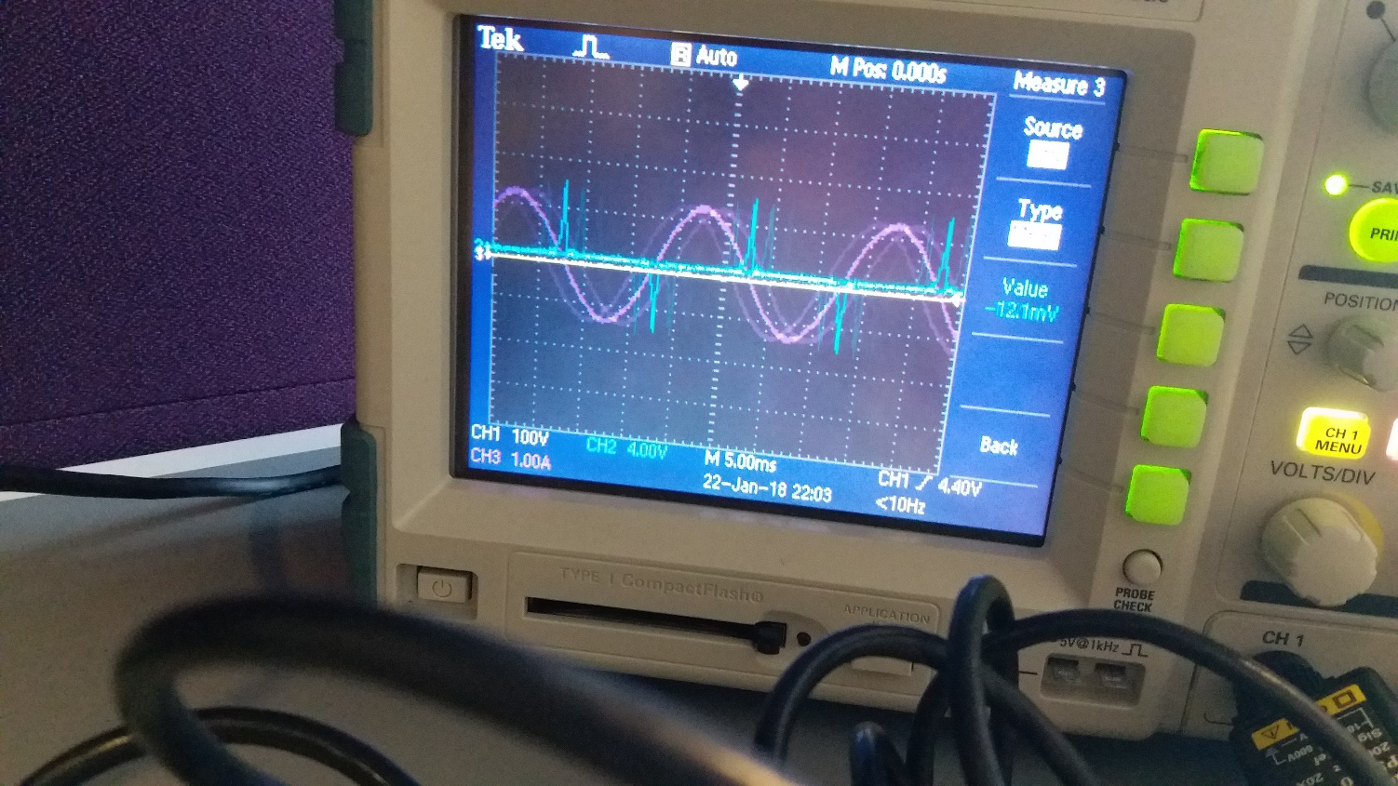

Figure 1.Saturation of Inductor Experimental Result

## TLP250 Tests (Duty Cycle and PWM)

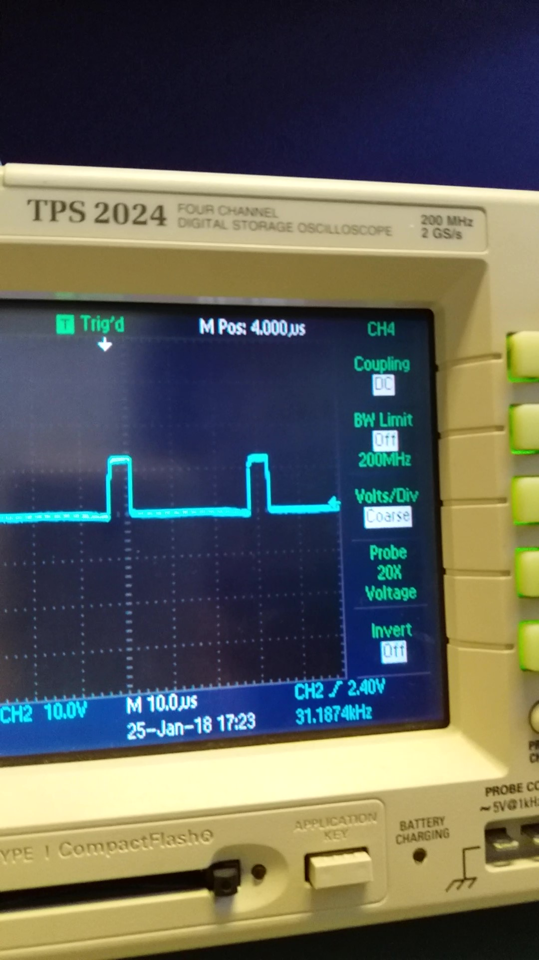

Figure 3.Output of TLP250 Duty Cycle at %15

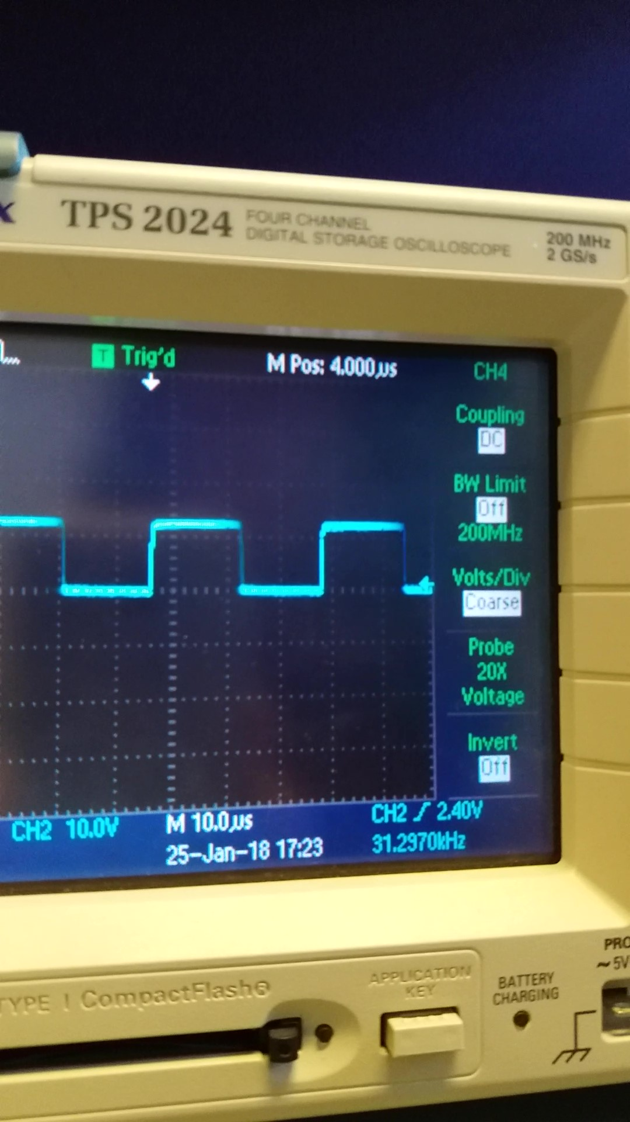

Figure 4.Output Waveform of TLP250 Duty Cycle at %50

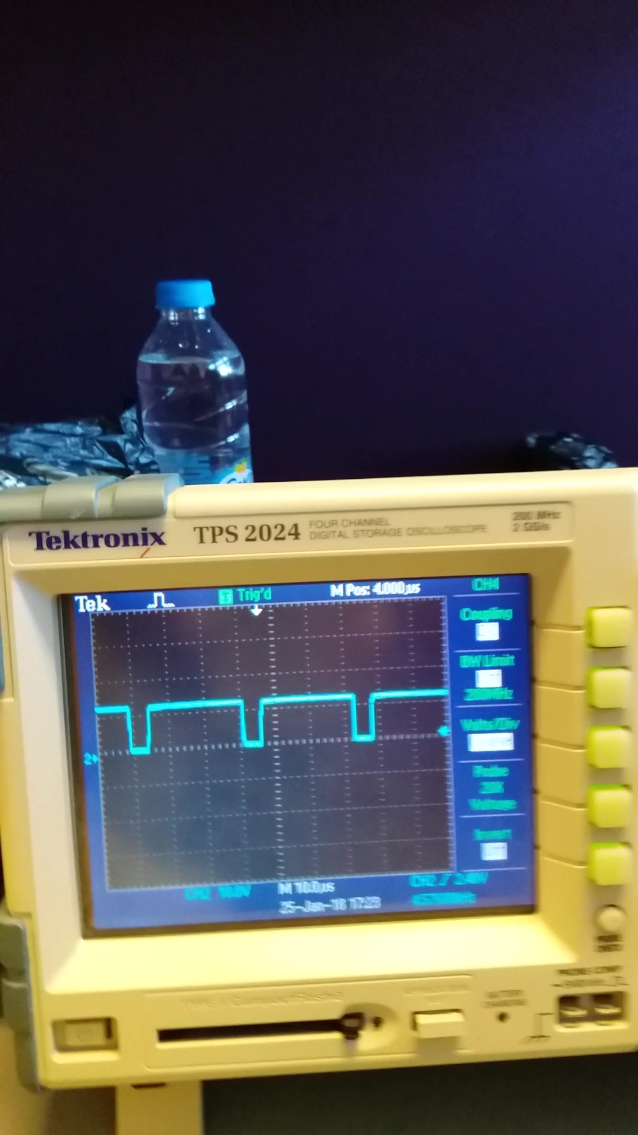

Figure 5.Output Waveform of TLP250 Duty Cycle at %90

## R Load Tests

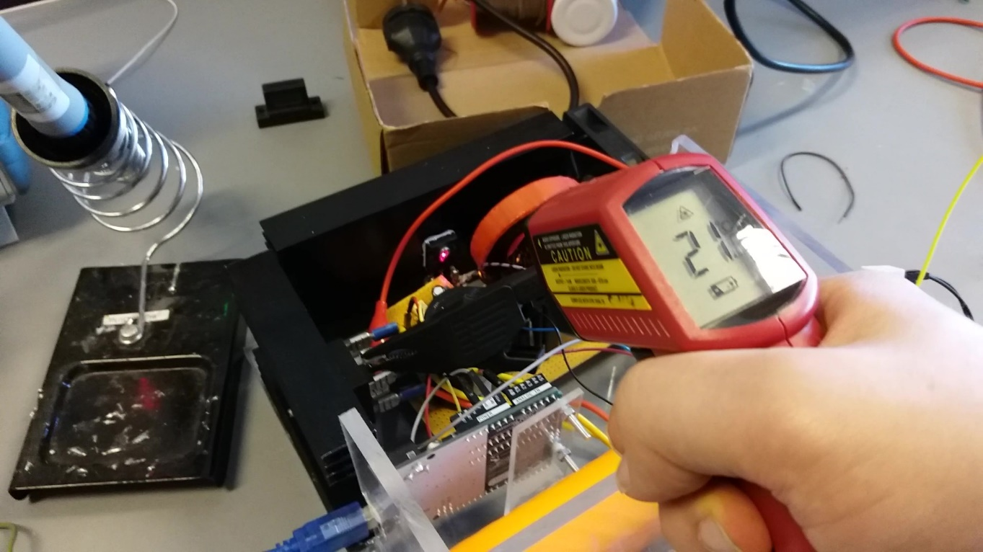

Figure 6.Temperature of MOSFET after 5 Minutes

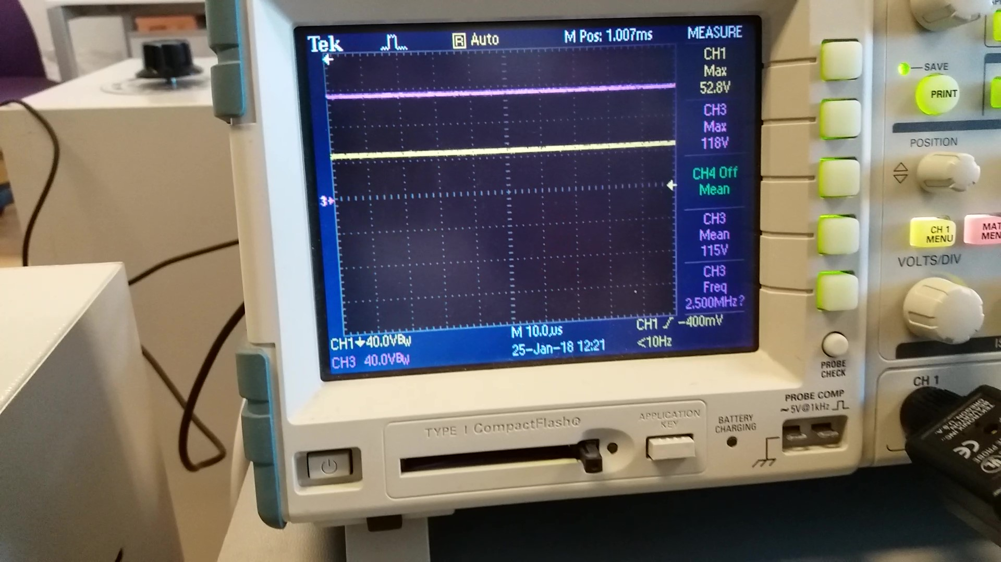

Figure 7. R-load Output Voltage(CH1) and Rectifier Output Voltage(CH3) at %30 Duty Cycle

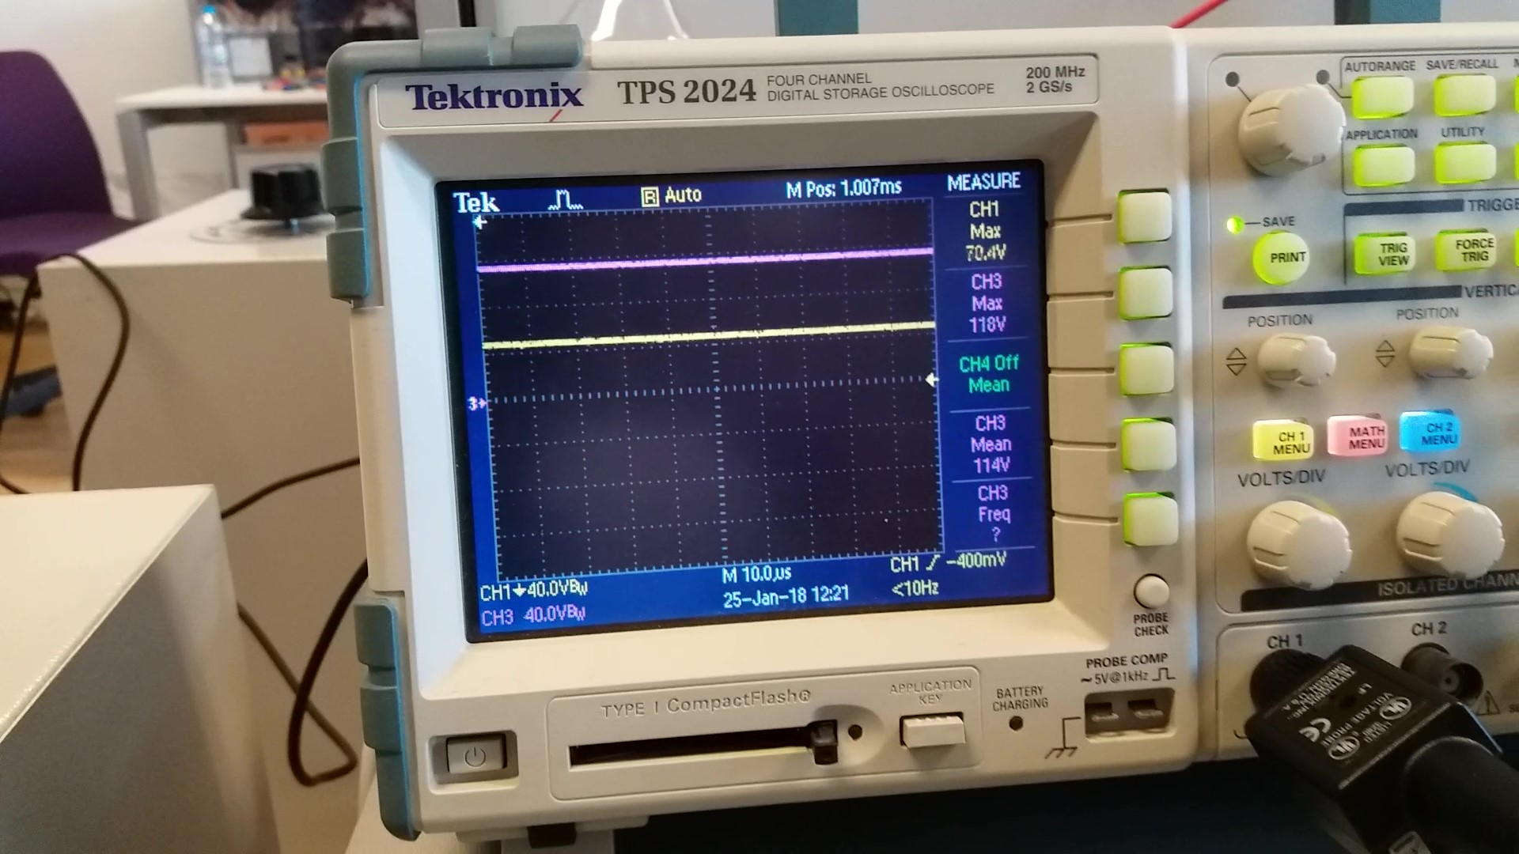

Figure 8 R-load Output Voltage(CH1) and Rectifier Output Voltage(CH3) at %60 Duty Cycle

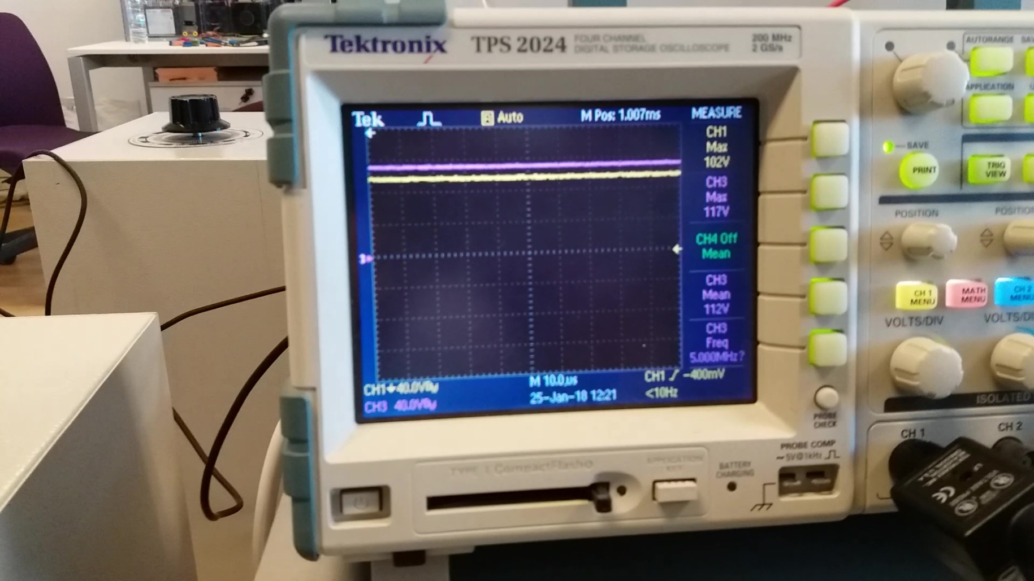

Figure 9 R-load Output Voltage(CH1) and Rectifier Output Voltage(CH3) at %90 Duty Cycle

## Motor Tests

## 

Figure 10 Temperature of MOSFET after 5 minutes (Motor at 220 V, with armature current of 1.6 A)

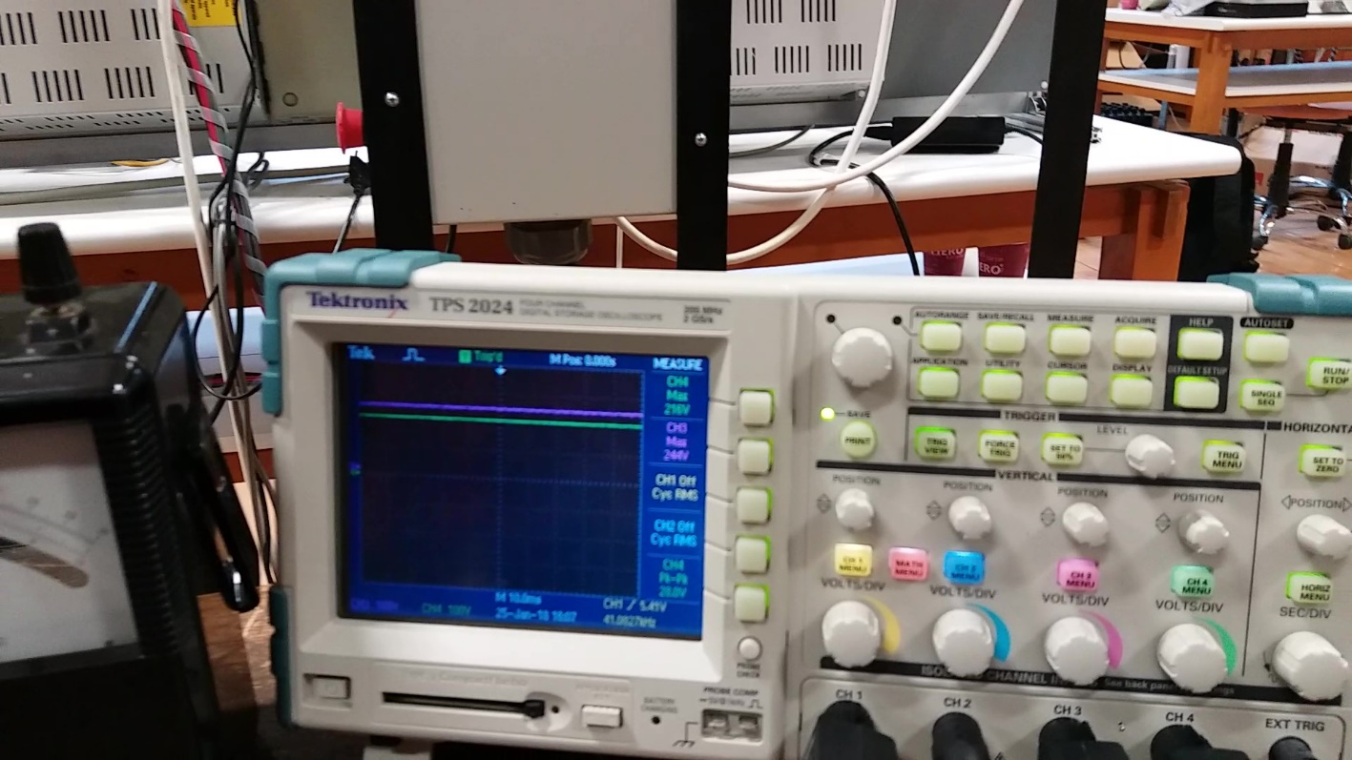

Figure 11 Output Voltage and Rectifier Output Voltage at %90 Duty Cycle

## 

Figure 12 Output Voltage and Rectifier Output Voltage at %60 Duty Cycle

## 

Figure 13 Output Voltage and Rectifier Output Voltage at %30 Duty Cycle

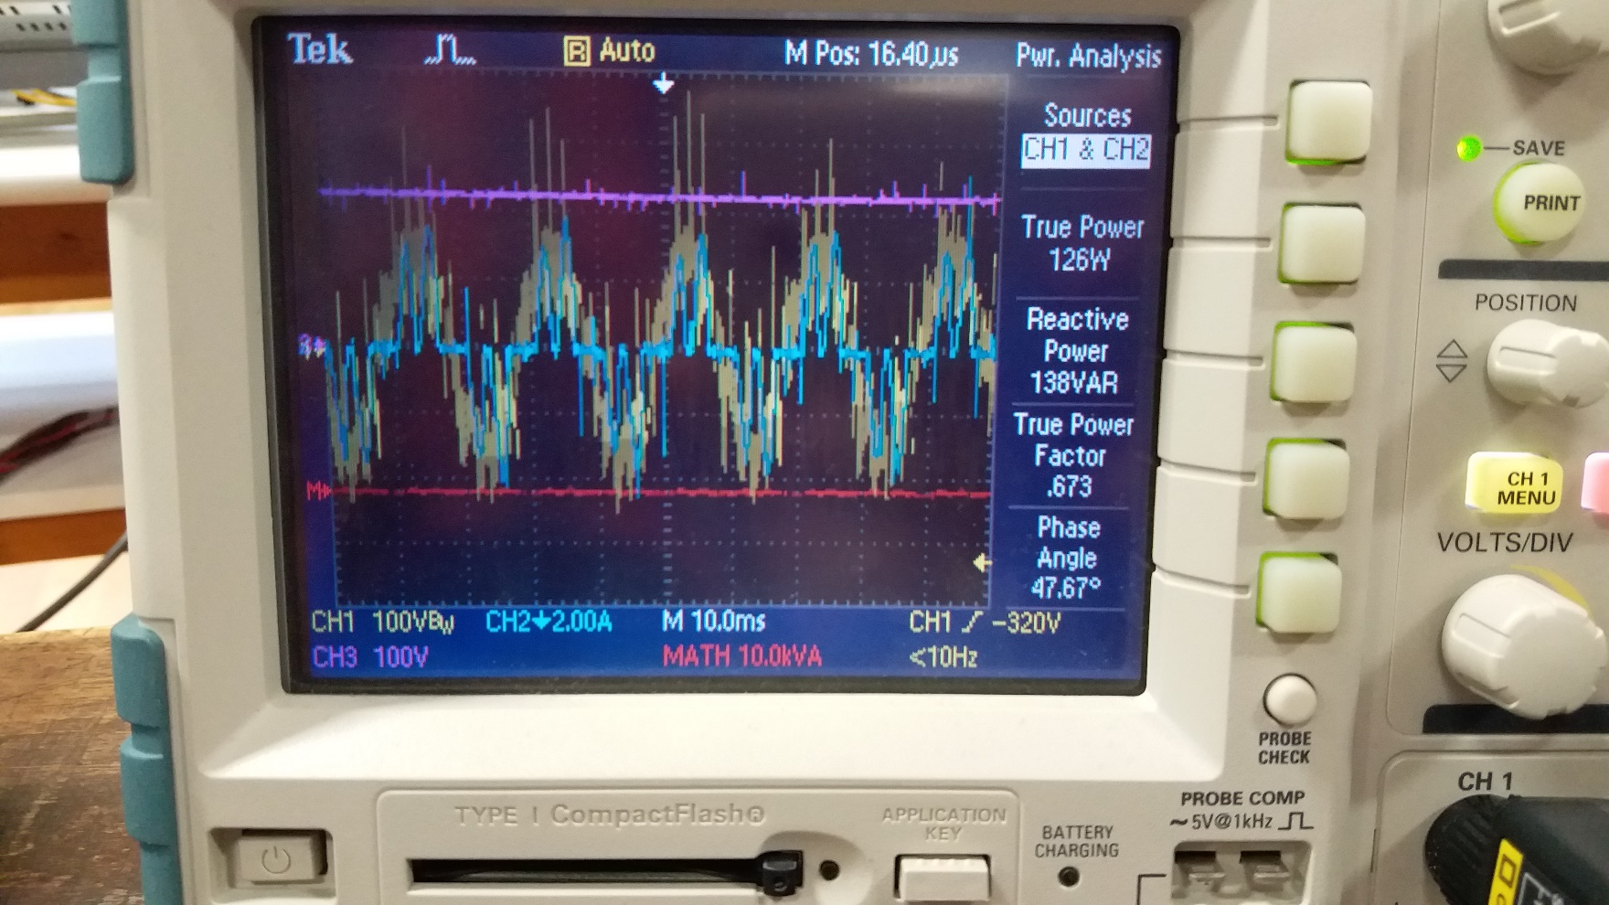

Figure 14 Input Power of System

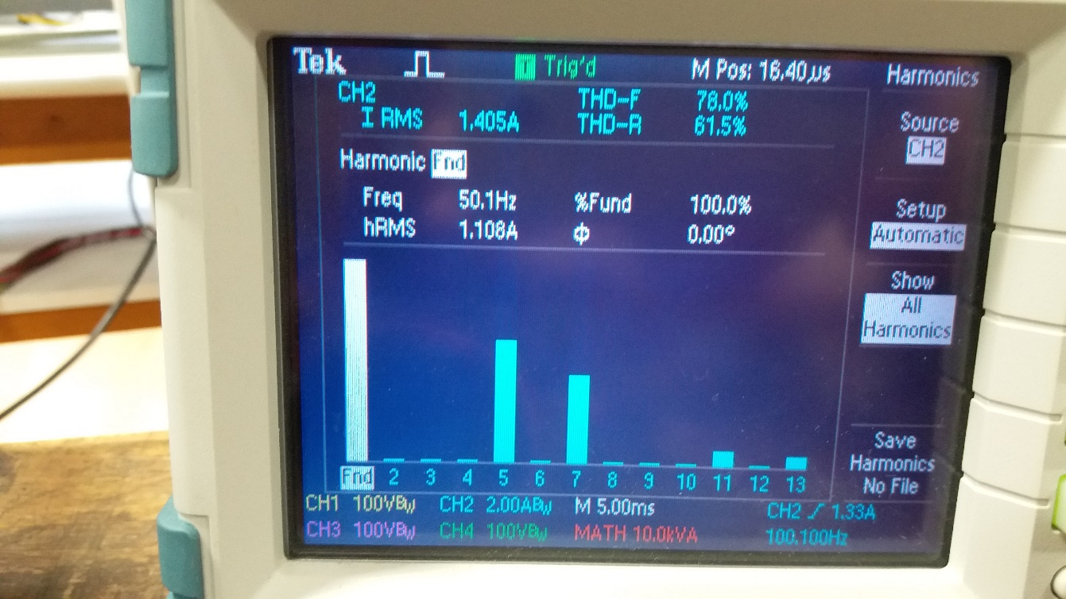

Figure 15 THD of Input Current

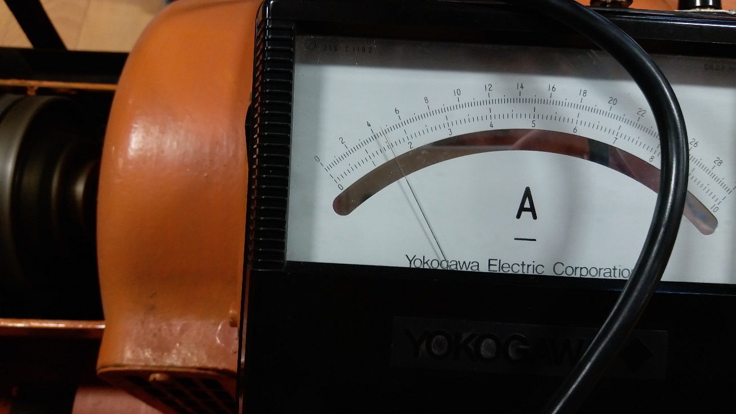

Figure 16 Output Current of System (Armature Current) When Output Voltage (Terminal Voltage) is 220V

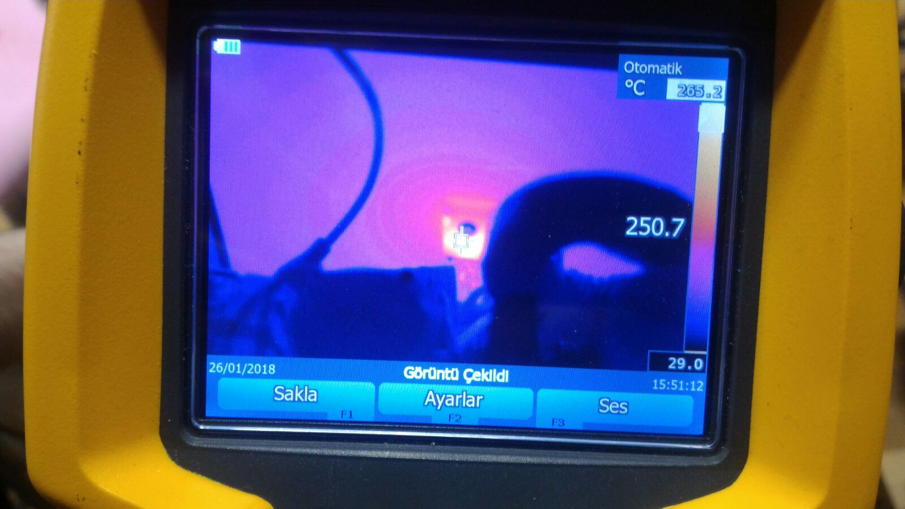

Figure 17 Temperature of MOSFET after 30 Seconds of Full Load Operation (12.7 A armature current)